**How to Complete an MEP EQUIPMENT CONSTRUCTABILITY REVIEW**

One of the many ways DPR determines the amount of risk involved in a project is through the review of the design documents. If the design documents are difficult to interpret or incomplete the project will be difficult to build, exposing DPR to more risk and unforeseen costs.

A constructability review enables you to define unclear or missing information prior to the start of construction. Communicating this information to the design team and owner can help align the team and clarify information prior to the start of construction.

Because of the criticality of USC NHC’s equipment, it is essential that the proper utilities are routed to each piece of equipment. Your task will be to review the utility requirements listed in the “MEP Equipment Cutsheets” and compare them with the “Medical Equipment Log” and confirm all of the required utilities have been included on the design documents.

INSTRUCTIONS:

1. Begin with the equipment log - select a piece of equipment to review. Identify the utilities that are required per the log. **All equipment you will need to review is highlighted in GREEN** (see below for example).

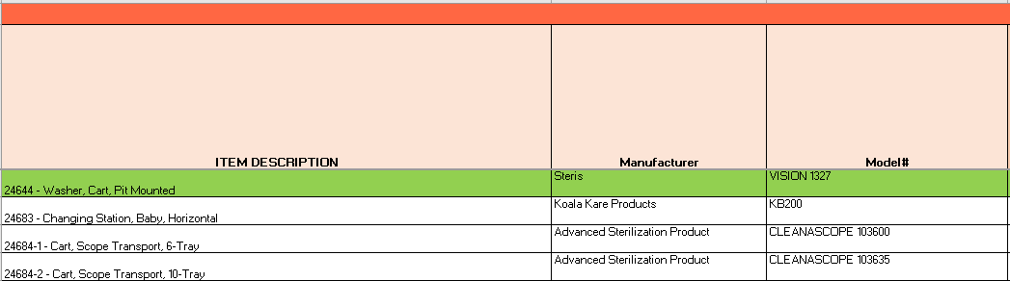

1. Review the cutsheets - Identify the utilities which are required per the cutsheets.
2. Locate the equipment on the MEP plans and confirm if the utilities have been shown on the drawings.

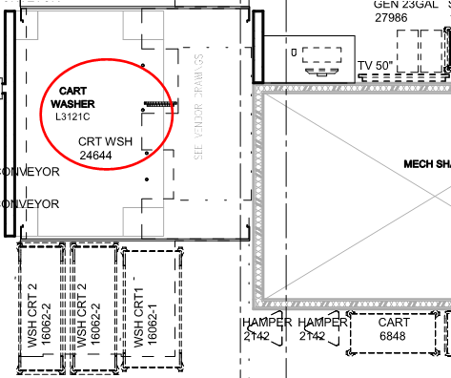

**Example –**

* 1. **Medical Equipment Log:** On the medical equipment log, it says thatEquipment #24644 requires hardwired power, a network port, compressed air, external exhaust, building steam, cold water, hot water, treated water, and a drain per the equipment matrix. Now review the drawings & equipment cutsheets to ensure they have also been incorporated into the design documents.



* 1. 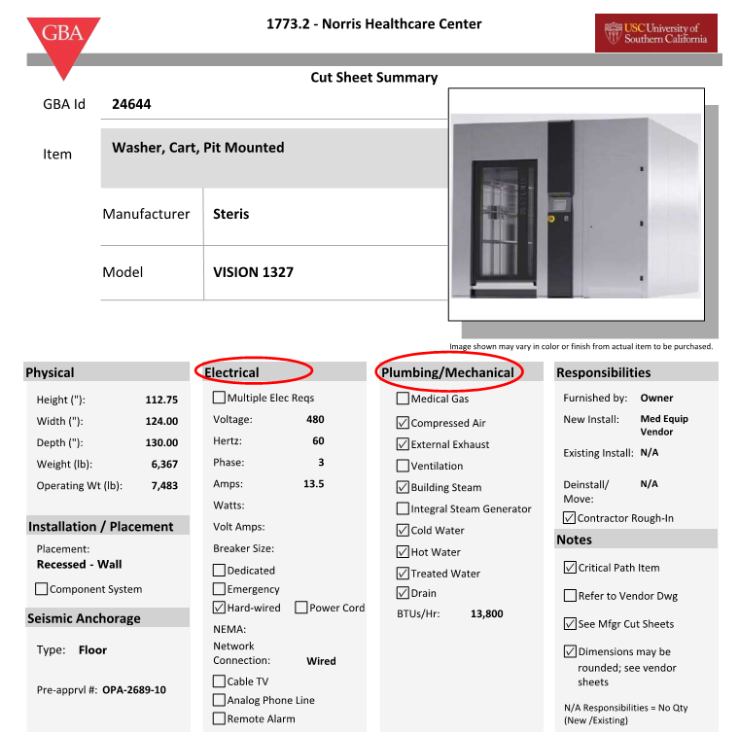**Cutsheet:** Verify that the requirements listed in the log match the MEP cutsheet requirements. 
  2. **Mechanical Plans:** No external exhaust is shown on the mechanical plans, but the building steam is shown (see highlight). We should make a note of this in the MEP Equipment Constructability Review Table.

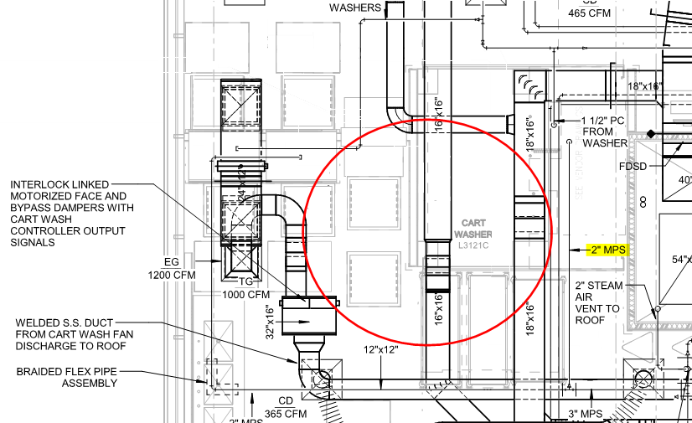

* 1. **Plumbing Plans:** All required plumbing is shown on the plumbing plans (see highlight). 

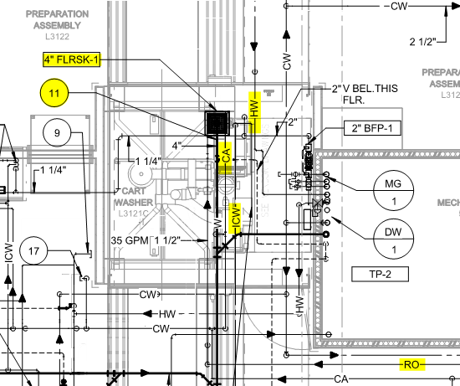

* 1. 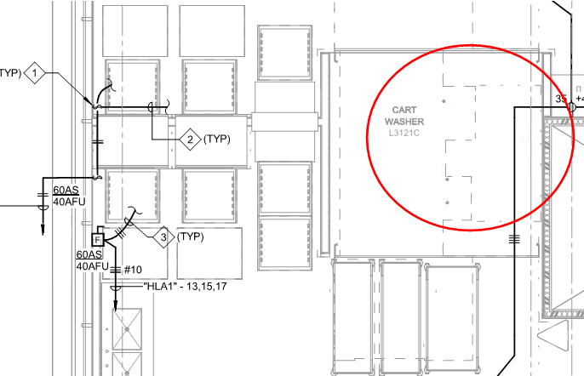**Electrical Plans:** The hardwired power is not shown on the electrical drawings. We should make a note of this in the MEP Equipment Constructability Review Table.
  2. **Telecommuncation Plans:** The network port is not shown on the telecom drawings. We should make a note of this in the MEP Equipment Constructability Review Table.

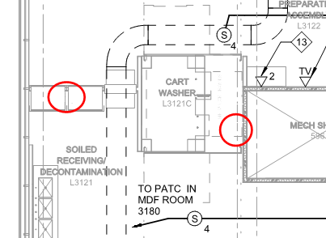

1. List any missing utilities from the design documents in the “MEP Equipment Constructability Review” worksheet. An example is shown below. This will be your final deliverable for this module.

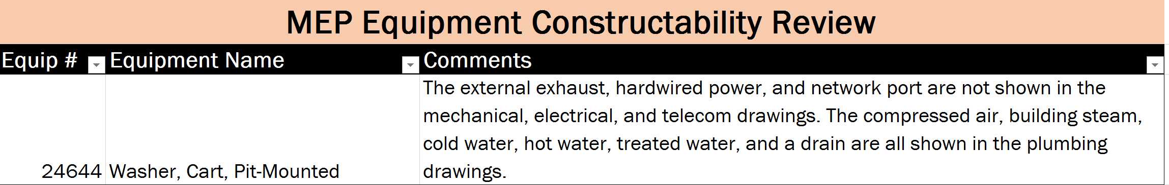

**HINT: RO means Reverse Osmosis which is referring to treated water requirements for the equipment.**