

USC NORRIS HEALTHCARE CENTER

PRECONSTRUCTION:

CONCRETE ESTIMATE PACKET

TABLE OF CONTENTS

1. Introduction 3
2. Instructions 4-7
3. Definitions 8
4. Video Resources 9

**INTRODUCTION**

# DPR Construction is a company built on the mission, ‘To Build Great Things’. One of the most important aspects of our company is that we are a self-performing contractor. Our founders aspire to one day self-perform an entire project.

# The self-performed group at DPR consists of teams within the company that specialize in specific trades. They bid, manage, and perform the work associated with their trade. Some of the self-perform divisions within DPR include: Concrete, drywall, surveying layout, Unistrut, ACT, and insulation. When owners allow DPR to self-perform work, it increases our fee while decreasing our risk. It also improves our control of safety, schedule, and cost management. Ultimately, this added control of our project benefits the owner.

This section will focus on our SPW Concrete division. You will create an estimate for SPW Concrete by performing a take-off of concrete foundations and selecting unit prices for the specific types of work. Remember to pay attention to the varied sizes and requirements of the foundation types identified.

**INSTRUCTIONS**

1. **QUANTITY TAKE-OFF**:

Review the structural items listed on the TYPE column of the ‘Concrete Estimate spreadsheet’. Open your drawings, specs, and details. Fill out the Description column.

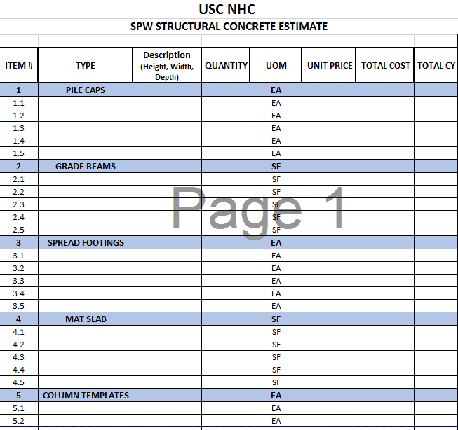

* 1. Enter your quantities into the ‘Structural Concrete Estimate’ spreadsheet.

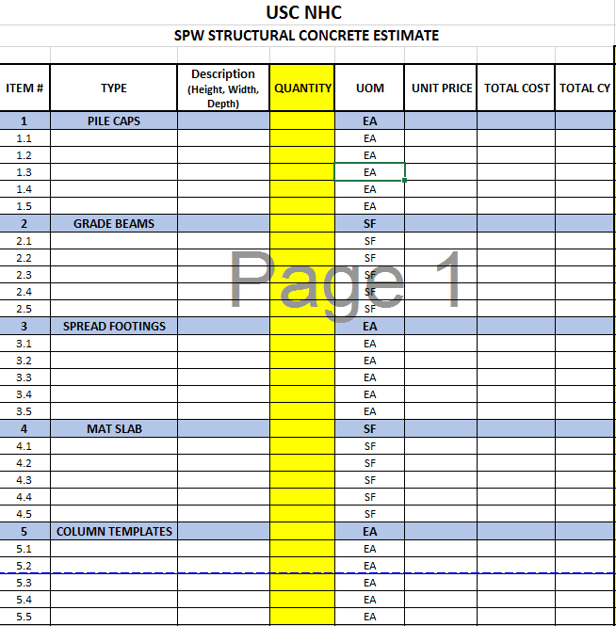

1. **DETERMING THE COST OF WORK**:
   1. The ‘Unit Cost’ Tab in the Concrete Estimate Spreadsheets file will be used to determine an estimate for the foundations. Choose items from this list and plug into the ‘Unit Price’ column on the ‘Structural Concrete Estimate’ spreadsheet. *Note: you may need to extrapolate by combining some items together.*
   2. Then fill out the Total Cost, Total CY of Concrete, Total SPW Structural concrete cost, and Total cubic yards needed for project.

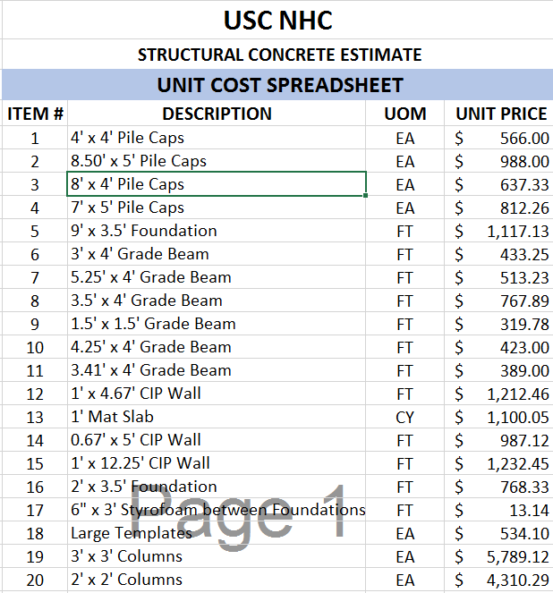

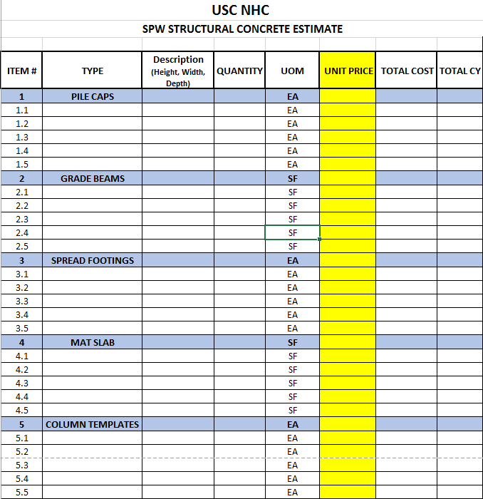

* 1. Once you have determined the total cost of work for the structural concrete for SPW, **INPUT** this cost into the designated line item in the Schedule of Values (SOV).

1. **CRITICAL THINKING:**
   1. We want you to ***DIG DEEPER***. As you are completing the SPW Concrete estimate, think about what risks we are taking on as a company and how we can mitigate them. This section may require some discussion with your teammates. Reference the critical thinking template for the questions to be answered. *Each response should be a minimum of 1-paragraph.*
2. **DELIVERABLES:**
   1. For the deliverables of this section, the following need to be provided:
      1. Take-off of Foundations
      2. Completed ‘Structural Concrete Estimate’ spreadsheet
      3. Critical Thinking Responses
      4. Optional: Bonus Question
3. **BONUS:**
   1. Mix designs come with various properties. We have provided a file of potential mix designs that have been submitted for approval. Identify the best mix design to be used for each of the items identified above. Remember to check your plans and specifications!

**DEFINITIONS**

1. **Self-Perform Work (SPW):** a scope of work which is performed inhouse by the General Contractor.
2. **Cement:** a powdery substance made up of lime, iron, silica, and aluminum; mixed with water, fine aggregate and coarse aggregates to make concrete.
3. **Concrete:** the chemical reaction of when water is added to cement with a mixture of coarse and/or fine aggregates.
4. **Admixture:** an ingredient sometimes added to the concrete mix design during batching to modify one or more of the properties of the concrete.
5. **Water-to-Cement Ratio (w/cm):** The is the ratio of the amount of water to cement within a concrete mix. The maximum amount is usually determined by the Structural Engineer.
6. **Grade Beam (GB):** a grade beam is used to support loads that have minimal bending. They help transfer the load of a shear wall equally among the pile caps and/or caisson footings (bearing points) below.
7. **Spread Footings (SF):** a spread footing typically carries a single column and helps to spread this load of the building laterally into the soils. Also known as an isolated footing.
8. **Continuous Footings (CF):** a continuous footing typically to constructed to provide a stable base around the perimeter of the building. Most commonly used where spread footings support the center of the building.
9. **Pile Caps (PC):** pile caps are masses of concrete connecting a group of previously constructed on piles driven into the ground. These typically form part of the foundations of the building.
10. **Mat Slab:** also known as a raft foundation, it is used to distribute heavier building loads across an entire section of the foundation.
11. **Slab-on-Grade (SOG):** slab-on-grades are also known as *floating slabs*, are typically a single layer of concrete, where it is thickened at the edges to create an integral footing.

**VIDEO RESOURCES**

If you need some helpful hints on how to do the take-off for this section, below are links to some ‘How To’ videos to follow if using either Bluebeam Studio or On-Screen Take-off.

1. **Bluebeam Studio:**
   1. Link: <https://youtu.be/gYAoTDZ3aEo>
2. **On-Screen Take-Off:**
   1. Link: <https://youtu.be/7b5qq3FKjwM>