**Smartsheet How-To**

Smartsheet is a web-based software that has Gantt chart capabilities. Very similar to other scheduling software you may have used, it allows you to insert tasks with durations and dates and set up dependencies to build a schedule. Best of all, its free to use for a 30-day trial! Follow the steps below and utilize the links to understand the software. Its very user friendly, but if you’re having troubles watch the quick videos.

1. **Create an account online** [**https://app.smartsheet.com/b/signup**](https://app.smartsheet.com/b/signup)

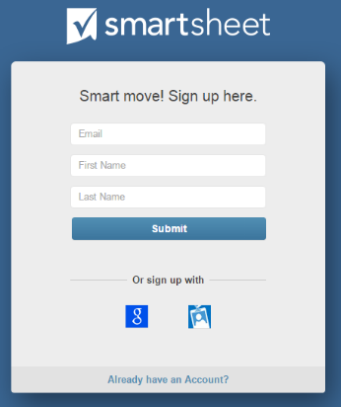

1. **From the homepage, click “ + Create New” to start a new sheet**
2. **Choose the “Basic Project with Gantt & Dependencies” template**
3. **The sheet allows you to type task names, dates, durations, and predecessors directly into the spreadsheet, or drag from bar to bar to create relationships. To understand all the tools at your disposal utilize the links below**

* How-To Video (4:16) <https://www.youtube.com/embed/WBUnbrN4UvY>
* Template How-To Webpage <https://www.smartsheet.com/solutions/basic-project-with-gantt-and-dependencies?tmgl=7D0ii8KknF2lW34WkeRubg>

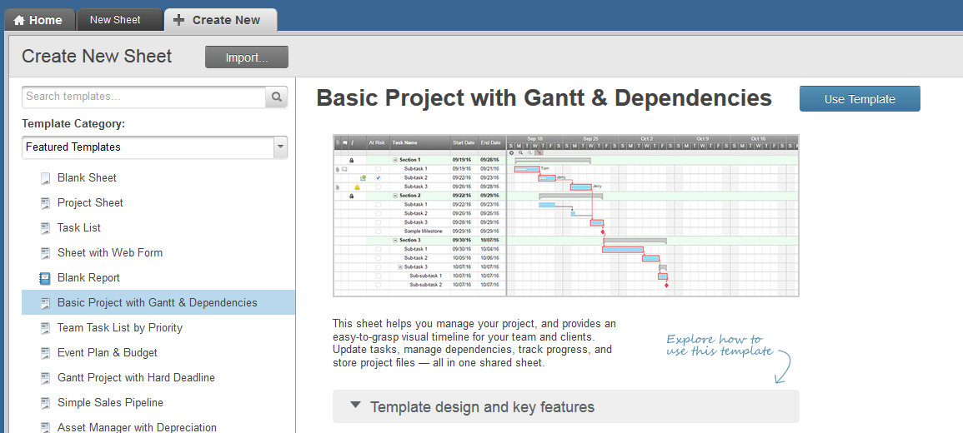

**Additional Tips**

* Rearrange columns to meet your needs and hide columns you may not use (% complete, assigned to, etc.)
* Change the row colors to create a visual breakdown between task types, similar to a P6 layout
* If you change the duration to 0, it will automatically create a milestone
* Remember to save frequently in-case you lose your internet connection
* Use the “outdent” and “indent” buttons to create summary activities and sub-tasks
* In the predecessor box, click on the small edit button to change the relationship to Finish-Start, Finish-Finish, etc.
* 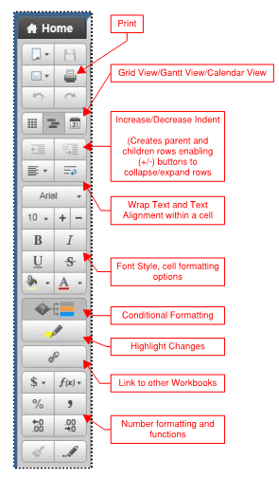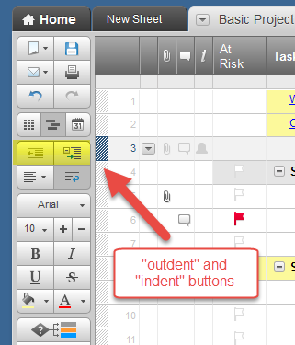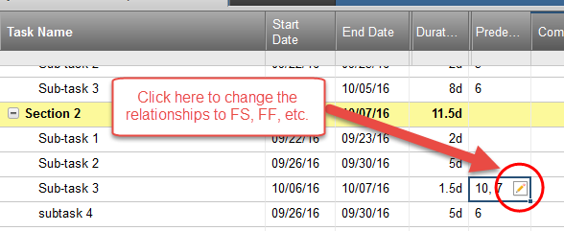Click the gear logo, at the top of the Gantt view to change the project settings and modify working days