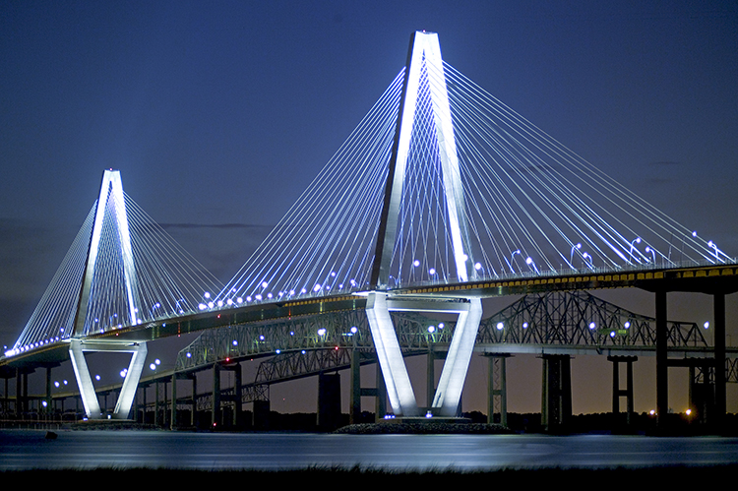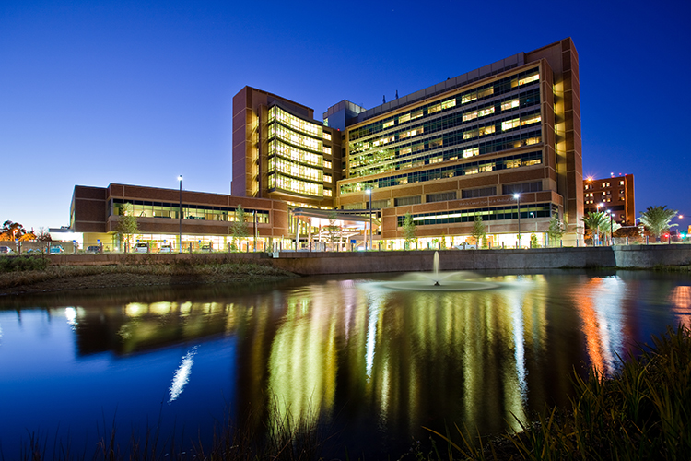

Associated Schools of Construction

Student Competition - Sparks, NV
February 5 - 8, 2014

National Problem Statement:

Sustainable Building & LEED

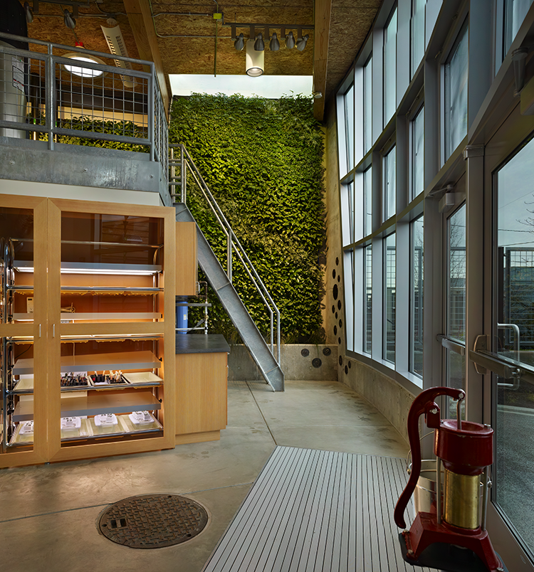

Introduction
Welcome to the 2014 ASC National Problem Statement focusing on Sustainable Building and Leadership in Energy and Environmental Design (LEED®) projects.

As one of the top Contractors of sustainable construction projects, Skanska USA has strived to create projects that have minimal, if any, impacts on the environment throughout their construction and lifecycle. Utilizing the programs set forth by the U.S. Green Building Council, the International Living Future Institute, and other green certification agencies, along with forward-thinking project teams and design partners, we have sought to move farther down the path of “green building” using any and all methods available. With your help and participation in this problem statement, we hope that you will gain understanding and appreciation of the green building methods that the construction industry can employ in our day-to-day operations. More than that, we hope that you will look to implement these ideas into your daily lives outside the workplace.
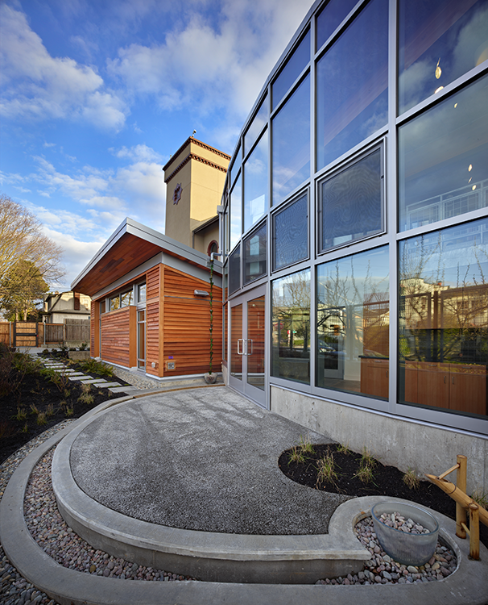

Project Description

The Milpitas Station project is part of the BART Silicon Valley Barryessa Extension, project which will provide a green alternative for thousands of daily commuters, reduce environmental impacts, foster transit use and walkability and preserve the character of established neighborhoods in Milpitas, San Jose, and the surrounding area. The building project includes a 91,000 square foot, 46’ high rail station with train platforms and shopping arcades. The site improvements include significant earthwork to accommodate the future rail lines.

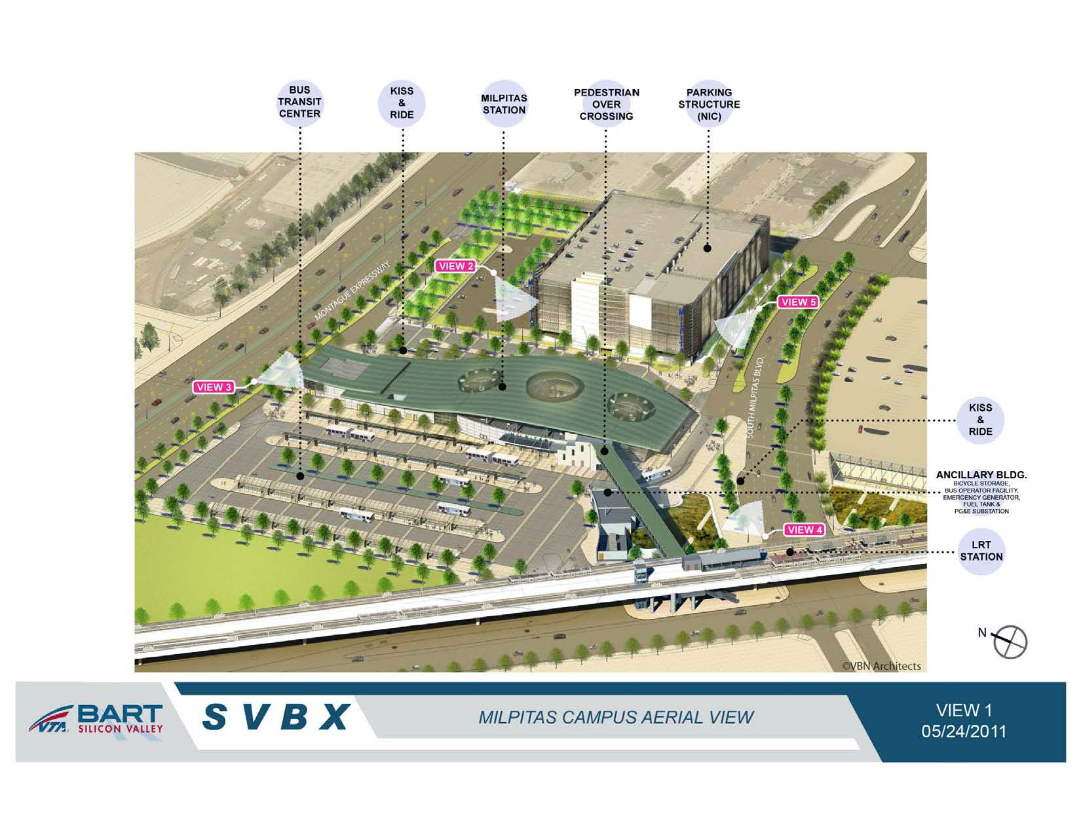

Scoring
The judging panel will be made up of four or more members from the project architect, engineers and general contractor. Point scales will be assigned to several elements of the written and oral presentations.

 |  | Available Points
 | Prequalification: Your team’s; actual resumes, personnel experience and commitments to sustainable design and green building, presented as a pre-conference submittal. | 5
 | Problem Statement 1 – Construction Water Reuse. | 15
 | Problem Statement 2 – Roofing & Skylights. | 10
 | Problem Statement 3 – Energy-Efficient Escalators. | 15
 | Problem Statement 4 – Native Species - Landscaping. | 15
 | Problem Statement 5 – Carbon Footprint. | 20
 | Oral Evaluation: - Prepare and present a persuasive argument and recommendation for a problem unrelated to the written problems. | 20
 | Total Possible Points | 100

Schedule

The problem statement schedule is as follows:

- Monday, January 13th, 2014
  - 2:00 p.m. – Pre-qualification submittal delivered to Skanska USA.
- Thursday, February 6th, 2014
  - 6:30 - 6:45 a.m. - Teams will attend a Sustainable Building & LEED Problem Overview for the selected project and distribution of problem instructions and materials.
  - 6:45 a.m. - 8:59 p.m. - Preparation of written Problem Statement responses.
    - 9:00 a.m. – RFI Session #1
    - 2:00 p.m. – RFI Session #2
    - 5:00 p.m. – Final RFI’s due, no RFI’s will be accepted after this time.
  - 9:00 p.m. – Written responses to Problem Statement and documentation due.
- Friday, February 7th, 2014
  - 6:30 a.m. - Turn in all oral presentation materials including handouts, electronic presentation media and other materials to specified room.

  - 6:35 a.m. - Lottery for Oral Presentation Schedule.
  - 9:00 a.m. - 4:30 p.m. - Oral presentations. 5 minutes setup, 15 minute presentation, 5 minute questions and answer period and 5 minute breakdown period.
  - 6:30 p.m. - Debriefing of project Problem Statement.
  - 7:00 p.m. to 8:00 p.m. – Hospitality Event
- Saturday, February 8th, 2014
  - 12:15 p.m. - Awards Presentation

Required Materials for Problem Statement

Submission Guidelines:

In keeping with sustainable practices, all proposers will provide a “Paperless” submission. Email attachments, flash drive and/or Compact Disks (CD) are the only acceptable means of submission materials. All electronic submissions must be in the form of a PDF, MS Imaging file, JPG, TIF or other electronic format. PDF is the preferred file format for submission.

Requests for Information:

A blank form for Requests for Information (RFI) is included as an attachment for use in submitting questions. Two question and answer periods will be scheduled during the day for informal questions, but all teams must submit written RFI’s if a formal response is requested. All RFI requests received will be provided as a response to all teams.

Format of Submission:

In addition to the requirements for electronic submission noted above, the following proposal formats must be adhered to:

- 12-point Times New Roman font
- 1-1/4” border around all documents, left justified
- All text single spaced
- Maximum submission of 25 pages, including cover page, cover letter, schedules or other documentation necessary to support your submission.
- Internet accessibility is allowed and required for your research and submission assistance.

A ten (10) point deduction from the overall team score will be assessed for pages in excess of the page limit described above.

Problem Statement 1: Construction Water Reuse
15 Possible Points

Intent: Reuse groundwater collected during dewatering of Milpitas Station trench for dust control and other water uses on site.
Part 1: Groundwater Produced – 5 Points
Determine the amount of groundwater produced from 50 ft. sections of the Milpitas Station trench (STA 371+00 to 380+00). Using a flow net approximation (or similar), what is the average expected gallons per week that must be dewatered?
Part 2: Groundwater Discharge – 2 Points
The cost to discharge into the sanitary sewer system is $0.0015 per gallon and the monthly rental cost of settling tanks (required for the sewer discharge permit) is $2,495.00. Costs for storm drain discharge system are provided in Attachment #6 and the RWQCB permit is $11,000. Should groundwater be discharged into the sewer or storm drain system? What is the cost difference?
Part 3: Soil Conditioning – 5 Points
- A 42" waterline runs through the future Milpitas Station trench and must be relocated (See Attachment #7). Assume the following:
- 30 gallons of water per cubic yard of cut and fill material is required for dust control of excavated material and conditioning of backfill material.
- Unsuitable material will be encountered in all locations.
- A CLSM will be used as bedding.
- The crew will achieve a production rate of 40 ft. per day.
What is the weekly quantity of water needed from water trucks for haul off of spoils and conditioning of backfill material?
- Elsewhere on the job, 3 – 2,500 gallon water trucks are needed during the wet season (October 15 to June 15) and one additional 4,000 gallon water truck is needed during the dry summer months for dust control. Each truck averages 16 trips per day, 5 days a week in the winter and 6 days a week in the summer. What is the total water demand per week, including watering associated with the 42" waterline, and the total net difference between groundwater dewatered and water demand?
Part 4: Cost Savings – 3 Points
The cost to purchase water from municipal hydrants is $0.003612/gal. How much money can be saved if the water trucks use water from dewatering the Milpitas Station Trench instead of purchasing water? What is the net cost to discharge into the system selected in problem 2? Is that system still the preferred option?
Additional Information
Attachment #8 – Milpitas Station SOE Drawings
Attachment #9 – Milpitas Station Trench Schedule
Attachment #10 – Montague Trench Construction Dewatering and Discharge Plan

Problem Statement 2: Roofing and Skylights
10 Possible Points

Intent: To understand the importance of heat islands and their effect on the environment.

Part 1: Heat Island Effect - Roof – 7 Points
Using the plans and specifications provided, determine whether or not the specified roof meets the minimum requirements needed to achieve SS Credit 7.2 Heat Island Effect - Roof.

Your company has been tasked with supplying the calculations on this Credit for the LEED application. Show your calculations and values used for partial credit.

Part 2: Copper Roofing – 3 points
The owner has concerns about the Copper Roofing materials Patina over time and its effect on achieving this Credit 7.2, is this concerned justified? Please show your work for partial credit.

Additional Information
Attachment #11 – Roofing and Skylight Specifications

Problem Statement 3: Energy-Efficient Escalators
15 Possible Points

Intent: In an effort to reduce the overall energy consumption in the facility, the project team is considering installing energy-efficient escalators. The escalators are designed to go into “sleep mode” during low usage periods, which utilizes less energy.

Part 1: Energy Savings – 5 points
Assuming 20% energy savings (in $ and kwh) when operating in “sleep mode”, calculate the total monthly and yearly energy savings for all new escalators in the project. Assume escalators operate in “sleep mode” when passenger loads are less than 100 people per hour. Passenger load data has been provided in Attachment #12 for this calculation. Provide energy and cost savings calculations and references. Show all work.

Part 2: Converter Regeneration – 5 points
Calculate monthly and yearly energy savings (in $ and kwh) assuming all new escalators are equipped with “sleep mode” and downward traveling escalators are equipped with converter regenerating controllers which turn braking energy into electricity. Passenger load data and converter regenerating data has been provided in Attachment #12 for this calculation. Show all work.

Part 3: Carbon Dioxide Savings – 2 points
Using the energy calculations above, determine how many metric tons of carbon dioxide would be saved by using energy-efficient escalators. How many acres of trees would be needed to offset this same amount of carbon dioxide? Provide references and show all work.

Part 4: Barriers to Widespread Use – 3 point
Although there are demonstrated savings in energy, money, and carbon dioxide emissions that are all benefits of using energy-efficient escalators what are some barriers to their widespread use in the United States? How would you overcome these barriers to convince the local jurisdiction to approve the use of these escalators?

Problem Statement 4: Native Species - Landscaping
15 Possible Points

Intent: To promote a competitive subcontractor bid process that also incorporates features supporting sustainable landscaping.

Part 1: 2010 California Green Building Standards Code (CalGreen) Section A5.304.6 –
10 Points
Create one (1) Excel Bid Tally Sheet that enables you, the contractor, to compare proposals of four landscape subcontractors to supply and install landscaping that meets the criteria of the above referenced CalGreen Measure.
- The bid tally sheet should include, at a minimum, the following subcontractors bid information:
  - Price
  - Quantity
  - Distance from project
- Using the California Invasive Plant Inventory provided, check the plant species’ each bidder proposed and determine if the bids meet the CalGreen criteria.
- Provide your recommended winning subcontractor or a combination of multiple subcontractors.

Part 2: SS Credit 5.1 Native Non-Invasive Plant Species – 5 Point
The project seeks to earn LEED Credit SS 5.1. The owner has asked you, the general contractor, to devise a plan to meet the credit criteria. Based on information provided in Part 1 and your recommended winning bid, does the project satisfy LEED Credit SS 5.1?
Show work that supports your answer, and explain the benefits of replanting areas disturbed by construction with native or adaptive vegetation at the Milpitas Station campus.

Additional Information
Attachment #13 – Landscaping Bids
Attachment #14 – Milpitas Campus Aerial Map
Attachment #15 – California Invasive Plant Inventory
Problem Statement 5: Carbon Footprint
20 Possible Points
Intent: In order to reduce the carbon footprint of the Milpitas station, the project team is investigating alternative concrete mix designs.
Using the provided concrete volumes and mix designs, research the supply chain of concrete ready-mix from the two suppliers and determine how to create the lowest impact mix design.
- Assume cement alternative (fly ash or blast slag) has a negligible impact on the calculation
- Assume that the supply chain is per the attached graphic
- Assume that cement and aggregate comprise the majority of the impact and ignore other components such as water and admixtures
- Assume the same mix design will be used for all concrete elements
- Assume that the capacities of the different modes of transport are per the US Army Corps of Engineers guidelines
Part 1: Weight of Cement and Aggregate - 5 Points
Using the given mix designs and concrete quantities, determine the weight of cement and aggregate (in tons) that is required for the project.
Part 2: Transport – 2 points
What is the most environmentally preferable method of transport? Why?
Part 3 – Transport Trips – 5 Points
How many round trips will the concrete mix trucks make from the batch plant to the project site?
Part 4 – Supplier Selection – 8 Points
Which supplier and mix has the lowest carbon footprint? Explain how you reached your conclusion.
Bonus – Other Selection Factors – 3 Points
Given that the low carbon concrete provider has been determined, what are other possible impacts of that provider vs. the higher carbon impact provider? What other factors can influence the choice?
Additional Information
Attachment #16 – Milpitas Station Concrete Takeoff
Attachment #17 – Specified Mix Designs
Attachment #18 – Supply Chain Graphic
Oral Evaluation
Oral Group Presentation
20 Possible Points
Intent: Prepare and present a persuasive argument and recommendations.
Required:
In a 2013 speech Prime Minister David Cameron relayed the following story:
Founded in 1379, New College, Oxford is one of the oldest Oxford colleges. It has, like other colleges, a great dining hall with huge oak beams across the top, as large as two feet square, and forty-five feet long each.
A century ago, some busy entomologist went up into the roof of the dining hall with a penknife and poked at the beams and found that they were full of beetles. This was reported to the College Council, which met the news with some dismay, beams this large were now very hard, if not impossible to come by. "Where would they get beams of that caliber?" they worried.
One of the Junior Fellows stuck his neck out and suggested that there might be some worthy oaks on the College lands. These colleges are endowed with pieces of land scattered across the country which are run by a college Forester. They called in the College Forester, who of course had not been near the college itself for some years, and asked him if there were any oaks for possible use.
He pulled his forelock and said, “Well sirs, we was wonderin’ when you’d be askin’.”
Upon further inquiry it was discovered that when the College was founded, a grove of oaks had been planted to replace the beams in the dining hall when they became beetly, because oak beams always become beetly in the end. This plan had been passed down from one Forester to the next for over five hundred years saying “You don’t cut them oaks. Them’s for the College Hall.”
This story illustrates tremendous long term planning about sustainable building.
Prepare a presentation describing three innovative ways in which the construction industry could show long term planning about sustainability that could be applied to the Milpitas Station Project. Points will be awarded for innovative/creative ideas, feasibility, and thorough explanation of how the ideas will help the sustainability of future generations.
Presentation Timeline:
- Teams will be allowed a five (5) minute set-up period.
- Teams will be allotted fifteen (15) minutes in which to; introduce their team, present their information, and explain the expected challenges.
- A five (5) minute question and answer period will follow the presentation.
- Five (5) minutes will be allowed for breakdown.
- A computer with MS PowerPoint, a projector, and screen will be provided for presentation to the committee.
- Any other presentation materials required are to be provided by the team.
ALL ELECTRONIC AND HARDCOPY PRESENTATION MATERIALS ARE TO
BE DELIVERED AT 06:30 AM PST TO THE PRESENTATION ROOM ON THE
MORNING OF FEBRUARY 7, 2014.

Attachments to Problem Statement
- Milpitas Station Drawings (14 Files)
- Milpitas Station Trench Drawings (160 Drawings)
- Specifications Volume A (664 Pages)
- Specifications Volume B (1543 Pages)
- Blank RFI Form (1 File)
- Lake for Lease Scope (1 File)
- 42in Milpitas Pipeline (1 File)
- Milpitas Station SOE Drawings (1 File)
- Milpitas Station Trench Schedule (1 File)
- Trench Construction Dewatering and Discharge Plan (1 File)
- Roof and Skylight Specifications (1 File)
- Escalator Passenger Load Data (1 File)
- Landscaping Bids (1 Files)
- Milpitas Campus Aerial Map (1 File)
- California Invasive Plant Inventory (1 File)
- Milpitas Station Concrete Takeoff (1 File)
- Specified Mix Design (1 File)
- Supply Chain Graphic (1File)

