

NORTHERN CALIFORNIA DISRICT
226 Airport Parkway, Suite 150
San Jose, CA 95110
Lic. 519252
(408) 452-1800
(408) 452-1855 FAX

June 15, 2008

Mr. John E. Owner
City of San Jose
Department of Public Works
200 East Santa Clara Street
San José, CA 95113

Re: Restrooms at the Facility
San Jose Central Service Yard

Dear Mr. Owner,

As requested, Hensel Phelps Construction Co. has investigated the issue of the Central Service Yard not having a sufficient amount of men’s restroom facilities. In the investigation of this issue the plumbing code does not permit an uneven amount of restroom facilities. Also, legally the facility can not have more male restrooms than female due to Title 8 (Workforce Safety Code). If the Central Services Yard elects to install additional restrooms, all costs associated will be the responsibility of the City. HPCC maintains a high level of respect for the City of San Jose and the working relationship we have developed over the years. HPCC will continue to help in resolving this issue until a viable solution has been discovered and our client is satisfied.

Please notify Hensel Phelps Construction Co. if there is any other assistance needed to help resolve this issue.

Respectfully,

HENSEL PHELPS CONSTRUCTION CO.
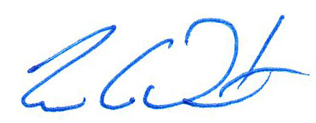
Tim C. Duerst
Project Manager

