

NORTHERN CALIFORNIA DISRICT
226 Airport Parkway, Suite 150
San Jose, CA 95110
Lic. 519252
(408) 452-1800
(408) 452-1855 FAX

June 15, 2008

Mr. John E. Owner
City of San Jose
Department of Public Works
200 East Santa Clara Street
San José, CA 95113

Re: Achieving LEED v2.1 Gold Certification
San Jose Central Service Yard

Dear Mr. Owner,

As requested, Hensel Phelps Construction Co. has looked into possibility of going from LEED Silver on the project to LEED Gold. Hensel Phelps believes that the project could achieve LEED Gold by achieving the following additional LEED credits:

- EA Credit 5 – Measurement & Verification
- MR Credit 7 – Certified Wood
- EQ Credit 1 – Carbon Dioxide (CO2) Monitoring
- EQ Credit 6.1 – Controllability of Systems, Lighting Control
- EQ Credit 6.2 – Controllability of Systems, Thermal Comfort
- ID Credit 1 – Innovation in Design: Additional Recycling

These credits were selected to minimize the amount of work needed to achieve LEED Gold and limit the impact the schedule. EA C.5 would be completed by the City after the project has been completed and has no impact on the construction schedule. EQ C.1, EQ C.6.1, and EQ C.6.2 will require upgrading the building controls and adding additional sensors. ID C.1 can be achieved due to the limited amount of finish on the project and the fact that we have metal structure and will just require additional documentation.

Should the City decide to make these changes it will have additional costs to the project. Certified wood carries a premium and there would be upgrades to the mechanical and lighting systems. Hensel Phelps will submit formal pricing for this issue should the City decide after reviewing this information they are still interested in achieving LEED Gold.

Please notify this office with any questions or concerns regarding this matter.

Respectfully,

HENSEL PHELPS CONSTRUCTION CO.
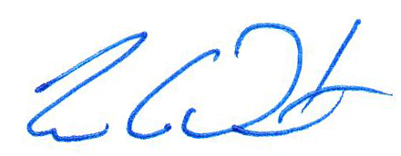
Tim C. Duerst
Project Manager

Attachment(s): LEED Gold Scorecard

