California Accessibility Quick Card

Based on 2013 CBC

# Doors

## MANUAL DOORS, DOORWAYS AND GATES

* Doors, doorways and gates that are part of an accessible route must be accessible.

## CLEAR WIDTH

* 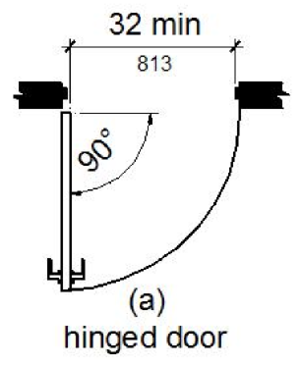Clear width of door openings: 32" min.

Figure : Clear Width

* Clear width of door openings greater than 24" deep: 36" min.
* Clear openings of doorways with swinging doors must be measured between the face of the door and the stop, with the door open 90°. Figure 1: Clear Width

## MANEUVERING CLEARANCES

* Maneuvering clearances must extend the full width of the door­way and the required latch side or hinge side clearance.
* Maneuvering clearances for swinging doors and gates: see Table 1: Maneuvering Clearances.
* Maneuvering clearances for recessed doors and gates: Maneuvering clearances for forward approach must be provided when any obstruction within 18" of the latch side, an interior doorway, or within 24" of the latch side of an exterior door­way, projects more than 8" beyond the face of the door, measured perpendicular to the face of the door or gate.

Table 1: Maneuvering Clearances

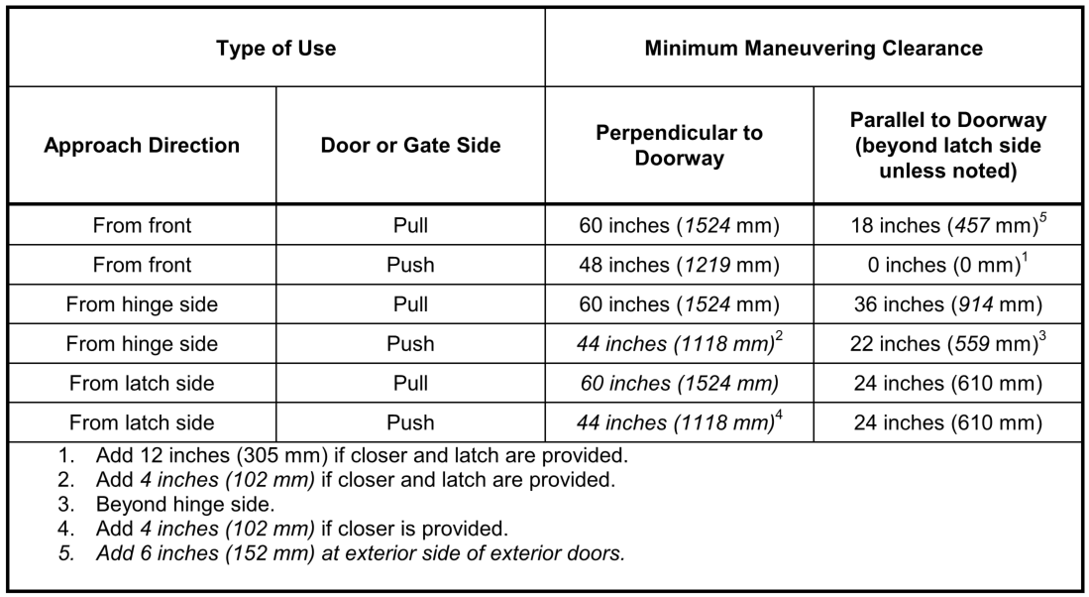

## VISION LIGHTS

* Doors, gates and side lights adjacent to doors or gates, containing one or more glazing panels that permit viewing through the panels must have the bottom of at least one glazed panel located 43" max. AFF

# Control Heights

## Electrical Receptacle Outlets, Controls or Switches

Controls or switches intended to be used by the occupant of the room or area to control lighting and receptacle outlets, appliances, alarms or cooling, heating and ventilating equipment must be located no more than 48" measured from the top of the outlet box nor less than 15" measured from the bottom of the outlet box to the level of the finish floor or working platform.

# Protruding Objects

## Protrusion Limits

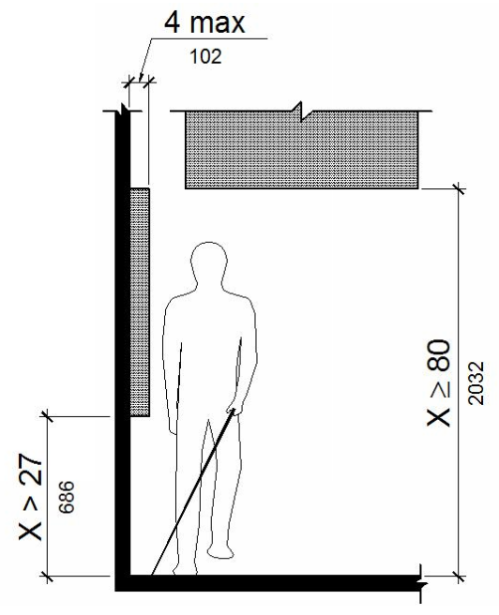Objects with leading edges more than 27" and not more than 80" AFF or ground must protrude 4" max. horizontally into the circulation path.

## POST-MOUNTED OBJECTS

Free-standing objects mounted on posts or pylons must overhang circulation paths 12" max. when located 27" min. and 80" max. AFF or ground. Where a sign or other obstruction is mounted between posts or pylons and the clear distance between the posts or pylons is greater than 12", the lowest edge of such sign or obstruction must be 27" max. or 80" min. AFF or Ground.

## VERTICAL CLEARANCE

* Vertical clearance: 80" high min.
* Guardrails or other barriers must be provided where the vertical clearance is less than 80" high.
* The leading edge of such guardrail or barrier must be located 27" max. AFF or ground.

# Water Closets

## LOCATION

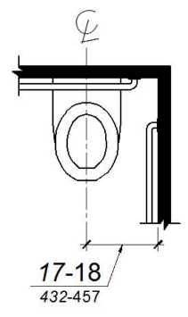

Figure : Water Closet Location

* Wall or Partition: The water closet must be positioned with a wall or partition to the rear and to one side.
* Centerline of Water Closet: 17" Min. to 18" Max. from centerline of water closet to side wall or partition.

## CLEARANCE

* Clearance Around Water Closet: 60" min. measured perpendicular from the side wall and 56" min. measured perpendicular from the rear wall.
* Maneuvering Space in Front of Water Closet: A min. 60" wide and 48" deep maneuvering space must be provided in front of the water closet. See Figure 3: Size of Clearance at Water Closets

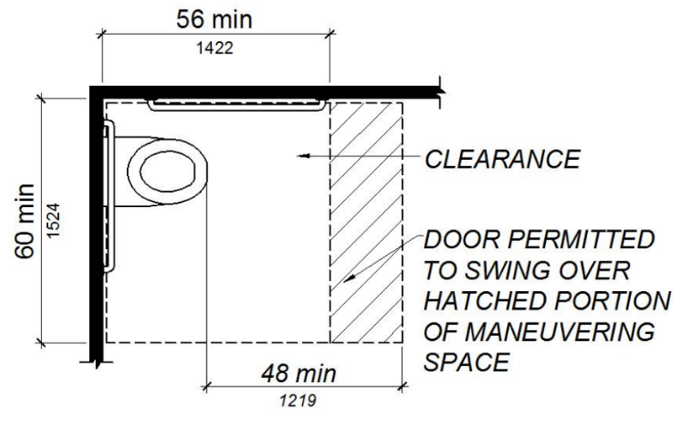

Figure : Size of Clearance at Water Closets

## OVERLAP

* The required clearance around the water closet must be permitted to overlap the water closet, associated grab bars, dispensers, sanitary napkin disposal units, coat hooks, shelves, accessible routes, clear floor coat hooks, shelves, accessible routes, clear floor space and clearances required at other fixtures and the turning space.
* No other fixtures or obstructions must be located within the required water closet clearance.

## SEATS

* Seat Installation Height: 17" min. and 19" max., measured from floor surface to top of seat.
* Seat Height: 2" max.
* Seat Height Exception: 3", permitted only in alterations where the existing fixture is less than 15" high.

## GRAB BARS

* Grab bars must be provided on the side wall closest to the water closet and on the rear wall.
* Where separate grab bars are required on adjacent walls at a common mounting height, an L-shaped grab bar meeting the dimensional requirements must be permitted.
* Side Wall: The side wall grab bar must be 42" long min., located 12" max. from the rear wall and extending 54" min. from the rear wall with the front end positioned 24" min. in front of the water closet.
* Rear Wall: The rear wall grab bar must be 36" long minimum and extend from the centerline of the water closet 12" min. on one side and 24" min. on the other side.

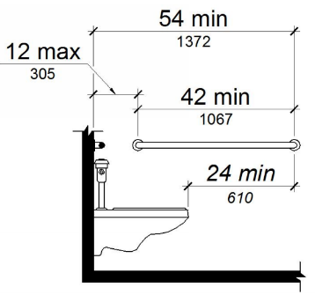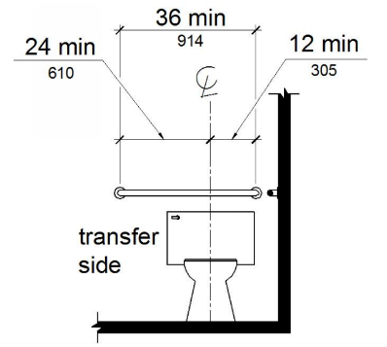

Figure : Side and Rear Grab Bar at Water Closet

## FLUSH CONTROLS

* Location: open side of the water closet.
* Installation Height: 44" max. AFF.
* Controls must be hand operated or automatic.
* Hand operated flush controls must be operable with one hand and must not require tight grasping, pinching or twisting of the wrist.
* Operation Force: 5 lbs. max.

# Lavatories

* Clear Floor Space: 30" Min. x 48" Min.
* If a min. of 9" height of toe clearance is provided, a max. of 6" of the 48" clear floor space may extend into space.
* Horizontal Depth: 17" Min. to 25" Max.
* Lavatory Height: 34" Max.
* Centerline if Adjacent to Wall or Partition: 18" Min. from wall/partition to centerline of lavatory.
* Hand-Operated Metering Faucets Opening Duration: 10 secs. min.

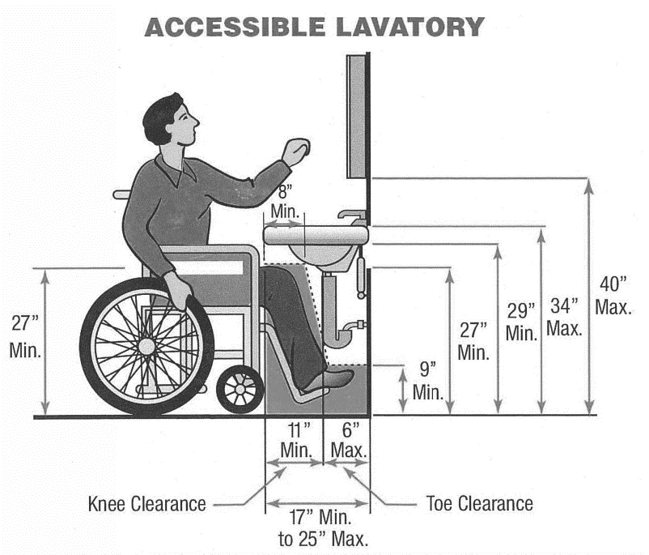

Figure : Accessible Toe and Knee Clearance

## Exposed Pipes and Surfaces

* Water supply and drain pipes under lavatories must be insulated or otherwise configured to protect against contact.
* There must be no sharp or abrasive surfaces under lavatories.

# Accessories

The following applies to restrooms:

* Accessories must be located on an accessible route.
* Operable parts must be provided with clear floor space of 30” min by 48” min.

## MIRRORS

* Mirror Height - When Located Above Lavatories or Countertops: 40" max. AFF or ground measured to the bottom edge of the reflecting surface.
* Mirrors Height - When not located above lavatories or countertops: 35" max. AFF or ground measured to the bottom edge of the reflecting surface.
* Mirror Height - Full-Length: 74" min. measured from the floor or ground to the top edge of mirror.

## HOOKS, SHELVES & CABINETS

* Coat Hooks Height: 15" Min. and 48" Max.
* Shelves Height: 40" min. and 48" max. AFF
* Medicine Cabinets Usable Shelf: 44" Max. AFF

## TOWEL, SANITARY NAPKIN DISPENSERS, WASTE

## RECEPTACLES & OTHER ACCESSORIES

* Operable Parts Height: 40" max. AFF

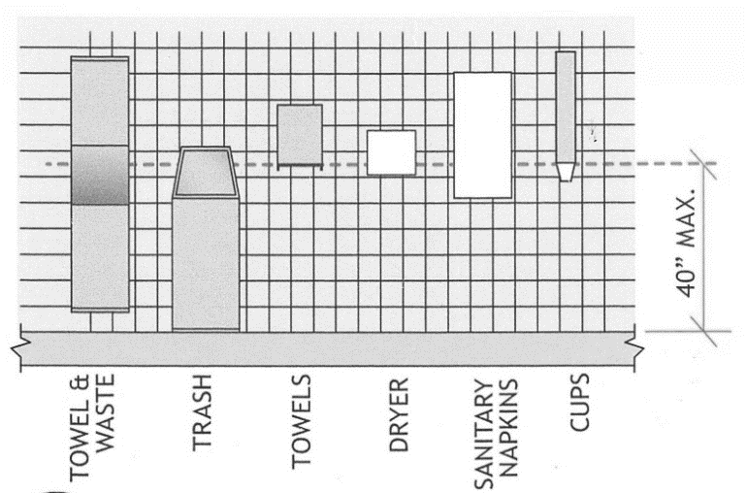

Figure : Accessory Reach Range

# Work Surfaces

Dining surfaces and work surfaces shall comply with Sections:

* Examples of work surfaces include writing surfaces, study carrels, student laboratory stations, baby changing and other tables or fixtures for personal grooming, coupon counters, and employee work stations.
* Clear Floor Space: 30" Min. x 48" Min. for a forward approach
* Knee and toe clearance be provided similar to Figure 5: Accessible Toe and Knee Clearance

## Height

The tops of dining surfaces and work surfaces shall be 28” min – 34” max AFF