**Activity Hazard Analysis (AHA)**

The basic steps included in an AHA are as follows:

1. Define the job steps being performed with the activity and identify the work sequences.
2. Identify the anticipated hazards.
3. Develop controls to mitigate the hazard. Consider ways to eliminate the hazard, if possible.



1. Identify equipment that will be used for this activity. Training and inspection requirements must be noted.



1. 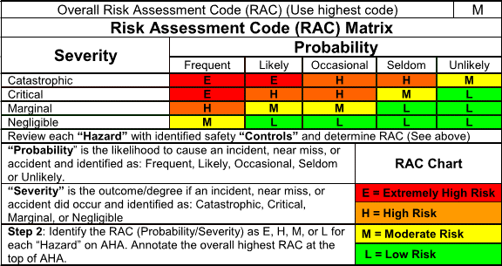Assign a Risk Assessment Code (RAC) to the activity.
   * Review each hazard for
   * “Probability” and “Severity” as defined on the AHA form (top of page one).
   * Write the corresponding RAC code on the AHA form for each activity.
   * After the RAC codes are assigned to each activity, locate the highest RAC code and put it in the upper corner of the first page.
2. The names of the competent and qualified person(s) required for that activity must be identified on the AHA.



Below is an acceptable example for a task in an AHA:

