

**Region 7- Commercial Building Division**

**February 8-10, 2018**

**Addendum #1**

**Proposal Summary**

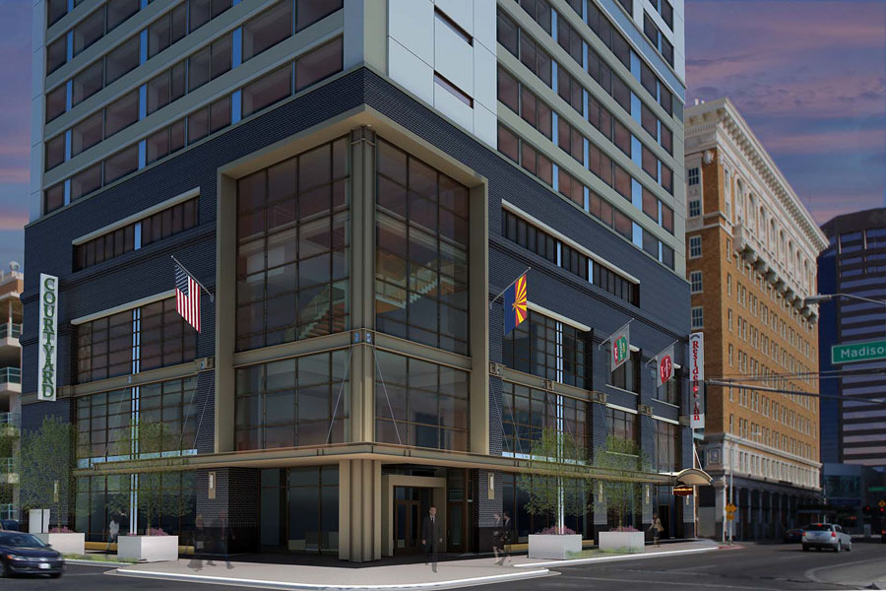

**LUHRS MARRIOTT**

**Phoenix, AZ**

**Problem Sponsor:**



Addendum #1

PROPOSAL SUMMARY (TAB ANALYSIS)

Written by Mike Giron & Michael Mourey

**Owner Request to Use Family Business**

During one of your first meetings prior to project award, the Owner states that he had a cousin by the name of Ignazio Lupo in the millwork industry and asked your team to review his cousin’s proposal for the millwork scope that has not yet been finalized. Your Project Manager assigned you to review the proposal against the other millwork proposals and provide him with an update of your review.

**Addendum 1 Deliverable:**

1. Include Ignacio Lupo’s quote evaluation as part of the millwork tab analysis provided in Problem Statement 4 on the Proposal Summary Bid Tab Section X.4.2.