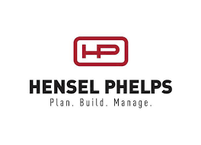

School Name:

Project: UCR MRB

Part D: Final Financial Status Report

Current Project Budget (prior to changes in contingency): $_________

Current Project Buyout Status: ___%

Suggested Changes to Contingency: ­­­___%

Anticipated Final Project Margin: ___%

Provide blanks above and brief narrative below: