Home Owner: Jeff Adams
Owner Address: 19651 State Route 534, Mount Vernon, WA 98274

Monthly Rate to temporary construction access onto Homeowner’s property: $2,500/month
Temporary Property Limits: See map and dimensions below, approximately 14,500 SF
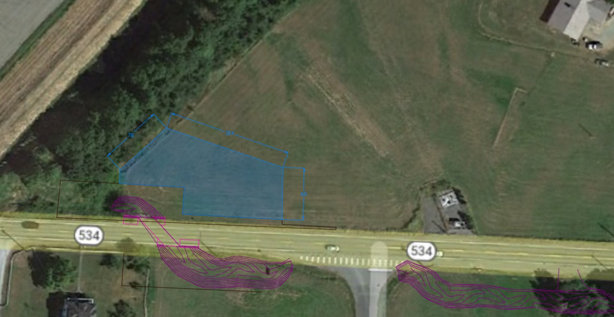

Land Use Inclusions & Clarifications:
- Temporary construction access within the limits shown in Attachment A
- Contractor is response to restore all disturbed areas to its original grade and seeded
- 30-day notice is required before entering premises
- Perimeter of temporary construction access shall be fenced off by Contractor during construction activities
- Homeowner is not responsible for permits or utility relocations
- Contractor is responsible for all damages within temporary property limits during construction activities.

