**Section IV – ESTIMATING**

710 Wilshire Hotel

Santa Monica, California

**PREMISE**

Morley Builders has been leading the preconstruction and estimating efforts for the 710 Wilshire Hotel project. The Owner has been eagerly awaiting the presentation of the construction estimate to determine whether the overall construction costs align with their proforma and if construction can commence as scheduled. Fortunately, you are the shrewd, efficient, and calculating estimator that needs to put the finishing touches on the estimate before the fast-approaching deadline. As part of the estimating team, you need to ensure that the estimate is accurate so that the Owner can make a timely decision and decide whether or not to move forward on a Guaranteed Maximum Price (GMP) Contract with Morley Builders. This exercise is important because it will establish trade line item direct costs and project indirect costs which the company will be responsible for throughout the course of construction. The primary component of the GMP will consist of a detailed Schedule of Values (SOV) of direct and indirect costs.

The team has identified the following items that they need you to include in the Solutions Binder:

1. Overall Project Schedule of Values (SOV)
   1. Subcontractor Bid Post of the Elevator and Site Utility Trade by completing the template provided.
   2. Street Rental Estimate Line Item to include in the Project SOV
   3. Remaining trade line items and indirect costs for the Project SOV by completing the template provided.
2. Full Size Mock-Up– Pricing to be included as an Alternate ADD to GMP.
3. Review and Estimate Mock-Up Drawings and complete Mock-Up Alternate ADD.

The following Exhibits are included in this section:

* + Exhibit IV.A.1 - Schedule of Values Template
  + Exhibit IV.A.2 – Bid Post Template
  + Exhibit IV.A.3 – Street Rental Template

1. **Creation of Schedule of Values (SOV)**

The Estimating Team needs you to finish the remaining trade line direct costs and indirect costs on the Estimate SOV left blank in Exhibit IV.A.1 before it is submitted to the Owner. This will determine a Guaranteed Maximum Price (GMP) for the project!   This SOV must include all direct costs, indirect costs and all below the line mark-ups. All of these costs will become the basis of the GMP Owner/Contractor contract.

The following subsections will need to be completed in order to completely fill out Exhibit IV.A.1 SOV Template Exhibit.

* + - 1. **Subcontractor Bid Posts**

Your team will be provided periodically with subcontractor bids via email for elevators and site utilities throughout the day for the work on the project. Read each bid carefully to determine the lowest complete bid for the associated work based upon the inclusions, exclusions, and qualifications by inputting the bids into the Exhibit IV.A.2 – Bid Post Template. The lowest complete bids should be used to complete the corresponding trade direct cost portion of the Exhibit IV.A.1 Schedule of Values Template.

See general description below on how to fill out bid post Exhibit IV.A.2 – Bid Post Template.

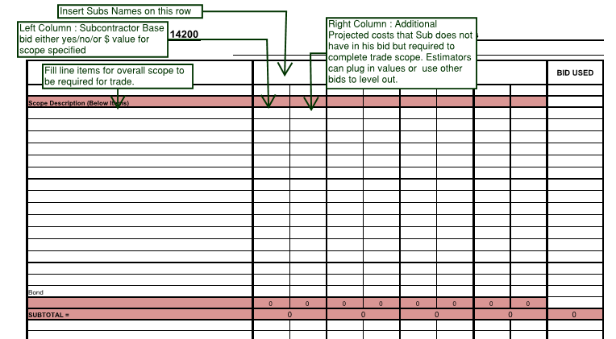

• If a Subcontractor has not specifically excluded an item, then you should assume that it is included.

• If a scope item has been excluded or left out of a proposal, you may use the right column of the bid tab in order to “plug in” the missing amount for the item, thus making the Subcontractor complete. Reference figure above.

• The lowest complete Subcontractor should be selected as the amount to be carried (bid used) and inserted into the Exhibit IV.A.1 Schedule of Values Template.

• Be flexible!!!! You will be receiving proposals throughout the day, you will need to read the proposals carefully and accurately quantify the proposals.

*Below are instructions from your project manager for additional clarification on the elevators and site utilities trade. There may be other additional projected costs so feel free to add additional projected costs in the scope description and the right column for each bidder.*

Elevators:

* The Wheel Chair Lift needs to be carried in the Elevator Trade
* Refurbishing of Elevator 1 and 2 needs to be carried in the Elevator Trade
* The Contractor needs to carry monies for additional fire caulking/grouting
* The Contractor needs to carry monies for elevator embeds this is not being carried in miscellaneous metals trade.
* The budget needs to have provisions for access controls and security cameras
* The contractor needs additional monies to protect elevator cabs during construction
* The contractor needs to carry operator time for elevator during construction
* No Bond to be provided for elevators.

Site Utilities:

* Only Wet Utilities is carried in this trade line. Dry Utilities is being picked up in the electrical trade line.
* The Contractor is qualifying that the City will make all water connections from street Main to the street side of the meter.
* The Backflow preventers will be picked up by the plumber or the fire sprinkler trade in their respective trade line.
* Utility Spoils are to be carried in Site Utilities even if Subcontractors do not include it in their proposal.
* Assume a 2% bond in your bid post to level both Subcontractors.

*Deliverable:*

Once you have assessed all the proposals within the Site Utilities and Elevator trade and selected your lowest qualified bidder, you will transfer the total estimated amount of each trade to your Exhibit IV.A.1 Schedule of Values Template. Also Include Exhibit IV.A.2 – Bid Post Template in the solutions binder for the elevator and site utility trade.

* + - 1. **Street Rental**

A line item in the General requirements (shown on the Project Schedule of Values Exhibit IV.A.1) not yet estimated is the street rental line item. Street rental allows the Contractor to rent the public right of way such as sidewalks and even street lanes for construction logistics. Since you need to finalize the estimate, you need to push the project superintendent to finalize the logistics plan and sequence so that you can quantify the cost of street rental for the entire project. You have already reached out to the traffic control company to get unit pricing on different street rental options (Reference Exhibit IVA.3 Street Rental).

Get a plan from your superintendent to correlate with the logistics plan. Will the construction team need sidewalks closed for the duration of the project? Will they also need parking lanes closed on certain streets for daily deliveries? Will the team need additional street rental for up/down tower crane(s) beyond parking lanes, maybe some single lanes? For concrete pumps and concrete trucks will additional traffic control be required? To flip the dirt ramp from the top of the hole is there need to be additional closures to accommodate these operations. These are just some events, not all inclusive, that may or may not need street rental depending on your site logistics plan.

*Deliverables:*

Utilize Exhibit IVA.3 Street Rental to list all the events and quantify the durations to arrive at the total street rental costs. Note that the City charges on a per SF basis and determines the frequency of when permit needs to be paid. The frequency is defined in Exhibit IVA.3 “Per” column. Once completed, input the street rental cost in the Project Schedule of Values Exhibit IV.A.1.

As part of your solutions binder turn in Exhibit IVA.3 with list of events and quantities.

* + - 1. **Remaining Trade Line Items and indirect costs in Project SOV**

*Balance of Trades (Remaining Direct Costs)*

For all other trades left blank put all quantities and costs into the Schedule of Values spreadsheet, see Exhibit IV.A, to complete the estimate and determine the total project cost.  Use of estimating guides such as RS Means and any other historical cost data are acceptable in developing the trade line item pricing. Utilize the unit of measure in Exhibit IV.A to determine your quantity take off and subsequently the unit price from RS Means.

*Indirect Cost: Gross Tax Receipt, Contractors Contingency, Insurance, Fee*

As part of this exercise, the team will need to determine the appropriate fee percentage. Please think about a reasonable fee % to present to the Owner. The fee percentage will be calculated on the direct costs and indirect costs (not including fee). Further the Gross Tax Receipt and insurance is to be calculated based total project costs including gross tax receipt, insurance and all other indirect costs.

*Deliverables:*

Complete/fill out all missing cost information and calculations on the Schedule of Values worksheet required to provide a total project cost and turn-in the completed Schedule of Values, Exhibit IV.A.1, in your Solutions Binder. Include all appropriate take-off/back-up.

1. **Full Size Mock-Up Alternate ADD**

The Owner would like to review the geometry and profiles of the exterior façade and the interior of a hotel model room. The Owner has directed the Architect to prepare drawings for a full size mock-up that they have saved the files onto the Bluebeam Project. The Owner would like to know the Alternate ADD cost of the mock-up at the same time the team submits the GMP. An Alternate ADD gives the Owner the ability to lock-in a price prior to executing a Contract without committing costs. The estimating team will be submitting the costs as a breakout estimate.

As part of the Owner’s request, you, the Estimator, will need to provide an Alternate ADD to the GMP Contract to furnish and install a full size mock-up per the “Mockup” drawings found on the bluebeam project. The mock-up is to be priced ONLY utilizing the mock-up drawings uploaded on the bluebeam project studio. This mock-up is for aesthetics review only and not a functional mock-up. You are to assume pricing the structure/exterior/interior and furnishing and installing MEP fixtures with no MEP rough-in required. Use of estimating guides such as RS Means and any other historical cost data are acceptable in developing the trade line item pricing.

*Deliverables:*

Provide a break-out estimate showing take-offs and pricing by trade for the Alt-ADD pricing of the mock-up and include in the Solutions Binder. Your estimating team will need provide their own estimate break out template for this section.