**A. Plan Reading & Photo Hunt**

Since Jefferson is occupied with keeping the project on schedule while leading field activities, he often will look to you provide information derived from the contract documents to keep work moving forward. Jefferson, and the rest of the field team, rely heavily upon your abilities to research and resolve unexpected issues that arise in the field, while communicating important information back to them and related trades in a short span of time. Below are the questions that Jefferson have asked you.

*Deliverable* – For each question below, provide an answer based on the plans and specs. Please write your answer directly on this form and return it with the Solutions Binder.

1. Where is the Remote CO2 Tank for the Pool and Spa supposed to be located?

_______A: Loading Dock_________________________________________________________

______________________________________________________________________________

1. How many total stair shafts are there in both the Landmark and Hotel Building? At what level does Stair #5 terminate?

_______A: 7 stair shafts. Stair #5 ends at Ground Level_________________________________

______________________________________________________________________________

1. How many floor sinks are there on the Cocktail Bar and Level 07 Kitchen?

______A: 9____________________________________________________________________

______________________________________________________________________________

1. What material is to be removed around the existing stair shafts in the Landmark Building?

_______A: Hollow Clay Tiles_____________________________________________________

______________________________________________________________________________

1. What type of waterproofing component is required directly over the tiebacks?

_______A: Two part expanding polyurethane foam filler/sealant (7- A-107)_______________ __________________________________________________________________________

1. Mechanical Equipment Room P-204 has a duct opening in the ceiling deck above. What is the size of this opening? Draw the required reinforcing around this opening.

_______A: 7’x4’ 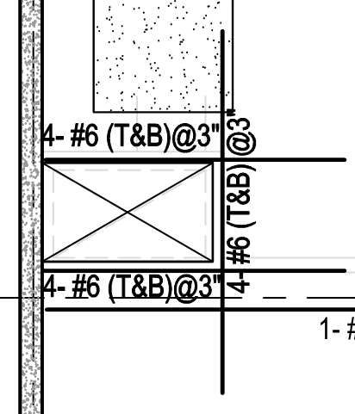_______________________________________________________________________

1. At what level is the Emergency Generator located? What are the sizes of the two vent pipes that feed this tank?

______A: Level P1 – 2” & 5” (P-205) ________________________________________________

______________________________________________________________________________

1. What is the minimum compressive strength column type C15 on GL Q & 4 on Level P4?

_____A: 6 ksi _________________________________________________________________

______________________________________________________________________________

1. What is an acceptable manufacturer for the exterior FRP (Fiber-Reinforced Polymer) on the Landmark Building?

_______A: Fyfe Co. LLC (See Spec Section 030172 2.1.A) ________________________________ ______________________________________________________________________________

1. What is the material that separates the crushed gravel and soil in the container planters?

______A: Geotextile Fabric ____(3-L106)_____________________________________________

______________________________________________________________________________

1. On the Ground Level at Gridlines 14 and L.7, there is a finish floor elevation of 116.42. Adjacent to this is a ramp that slopes down by 3.6%. What is the length of this ramp? Measurement to be in decimal form.

_______A: 30.27 feet___________________________________________________________

_____________________________________________________________________________

1. What is the rough opening size and finish material for the bathroom door at guest room 211?

______A: 3’-0” (See detail 3/A-227) and painted______________________________________

______________________________________________________________________________